**Deep RNN**

As we have deep mlp and cnn we also deep rnn

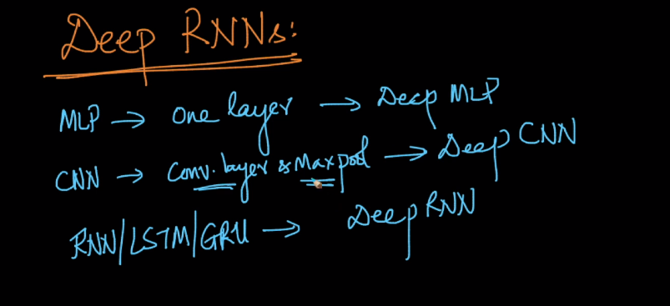

Below figure shows layers of rnn.

For back propagation we just have to turn the arrows.

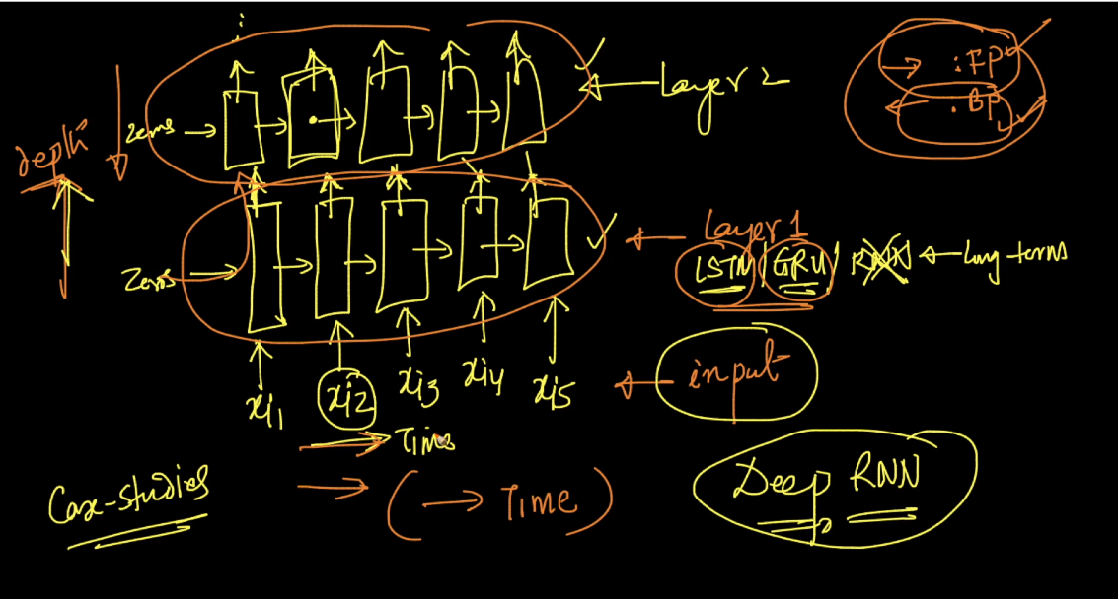

Deep rnn also have dropout , Bn , flattening layer

